Lab Rules and Safety Instructions

GENERAL RULES:
- Bags and personal belongings should be stored in the proper area, not on the bench tops or in the aisle ways.

- Eating and drinking is prohibited inside the lab.
- Discipline should be maintained inside the lab. Any horseplay will lead to immediate removal from the lab.
- Use of personal electronic devices is NOT allowed except with permission.
- Always perform experiment and use equipment under supervision.
- Avoid cluttered work environment.
- Scribbling on the workbench or any other item present in the lab is strictly prohibited.
- Lab items are not allowed to be taken outside the lab.
- Lab equipment/components will only be issued for lab performance and project testing.
- For using lab PC, login from your SHU student ID and contact IT department for any difficulty.
- Punctuality is the key to success. Attendance will not be marked after 15 minutes of lab start time.

SAFETY RULES:
- Always check for loose wires and connections before energizing any circuit or equipment.
- All personal accident, injuries and illnesses, however slight, occurring in the lab must be reported immediately to the instructor.
- Report any damages to equipment, hazards and potential hazards to the instructor.

- Always check to see that the power switch is off before plugging into the outlet. Also, turn power supply off before unplugging from the outlet.
- When unplugging the power cord pull on the plug of the cord, not on the cable.
- Always hold the alligator clip along rubber insulator covering it.
- Make sure that the connector of the probes are properly inserted into the power supply output terminals.
- Always use electrostatic discharge (ESD) mat while working with electrical circuits.
- Do NOT energize circuits unnecessarily for long time.
- When disassembling a circuit, make sure to first remove the source of power.
- Do not touch any electronic devices or equipment with wet hands.
- Do not plug any electronic circuit in power outlet without permission.
- Isolation should be maintained between high power and low power equipment.
- Use all devices/equipment safely and carefully.
- Always wear safety goggles when necessary.

- The table below lists the impact of AC (alternating current) on the human body/physiological system.
Current | Effect
1 – 5 mA | Threshold of sensation.
5 – 20 mA | Involuntary muscle contraction (can’t let go)
20 – 100 mA | Pain, breathing difficulties.
100 – 300 mA | Ventricular fibrillation, possible death.
>300 mA | Respiratory paralysis, burns, unconsciousness.

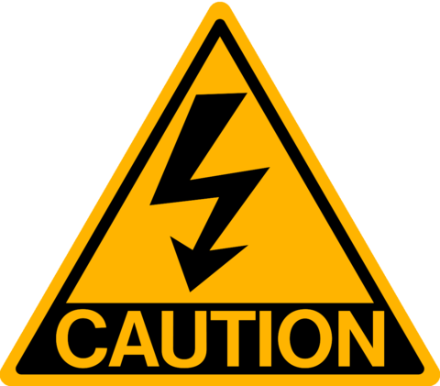
PC:
- Log-in the PC with your own SHU Student ID and Password.
- Avoid using the PC for purposes other than educational.
- Do not interface any device with lab PC without permission.
- Before leaving your workbench, switch off the PC properly.
DURING EXPERIMENT:
- Electronic devices and components can only be issued after submitting your SHU student ID card.
- Use precaution during experiment. Switch off the power supply before modification in live circuit.
- Use wires of suitable length for their appropriate application. Extended wires or connections can cause clutter on a bench while very short wire may be easily disconnected.

- When taking electrical measurements, form the habit of using only one hand at a time. No part of a live circuit should be touched by the bare hand.

BEFORE LEAVING THE LAB:
- Return all items issued for the experiment and inform instructor before leaving the lab.
- Switch off PC, electronic equipment and power to workbench.
- Make sure the workbench is left in well order.

I have read and understand the lab rules and safety instructions and am aware of the consequences of failing to observe them.

Full Name: ___________________________________________________________________________

Course: ___________________________________________________________________________

Signature: _____________________________________ Date: _______________________

INDEX
S.No. | Date | Experiment | Sign.
1
2
3
4
5
6
7
8
9
10
11
12
13
14
15

1 LAB EXPERIMENT

OBJECT:
To analyze the working of Basic Electrical components and Equipment’s.
LEARNING OUTCOME:
In this lab, students will be able to understand the following points:
- Basic Electrical components Power Supply. Oscilloscope, Function Generator, Breadboard, Multimeter.
- Basic Electrical Terms: Voltage, Current, Resistance and Capacitance.
- Designing and working of Series and Parallel Circuit.

INTRODUCTION:
- VOLTAGE:
Voltage can be defined as “The electric potential difference between two points “, or the voltage between two points is equal to the work done per unit charge against a static electric field to move a test charge between two points. To move a one coulomb charge across the one volt of electric potential required one joule of work. The symbol of voltage is uppercase italic letter V or E. Voltage also known as electromotive force (EMF). Its unit is Volt. Voltage are of two types direct or alternating. A direct Voltage have same polarity at all time, while in alternating voltage polarity reverse direction periodically.

Mathematical formula of Voltage is:

According to Ohm’s Law
$V=I×R$
Whereas,
$V$ = Voltage (Volts)
$I$ = Current (Ampere)
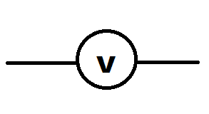
$R$ = Resistance (Ω)
General symbol of Voltage source is used as:
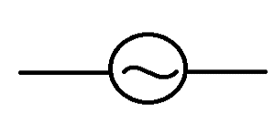
AC symbol of Voltage source:
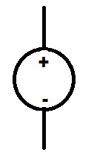
DC symbol of Voltage source:

- CURRENT:
An Electric current is a stream of electric charge. In electric circuit this charge is frequently conveyed by moving electrons in a wire. Symbol of current is I and the SI unit of current is “Ampere”. One ampere of current represents one coulomb of electric charge (6.24 x 1018 charge carriers) moving past a specific point in one second. Physicists consider current to flow from relatively positive point to relatively negative point; this is called conventional current or Franklin current. Electron the most common charge carrier, are negatively charged. They flow from negative point to positive point. Electric current can be direct or alternating current. Direct Current (DC) flows in the same direction at all the points in time, although the instantaneous magnitude of current might vary. In an alternating current (AC), the flow of charge carries reverse direction periodically.

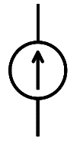
General Symbol of Current Source is:

Mathematical formula of Current is:
$$I=\frac{Q}{T}$$
$I$ = Current (Ampere)
$Q$ = Total Charge
$T$ = Time

- RESISTANCE:
Resistance is the resistivity that a substance offers to the flow of electric current. Symbol of resistance is Ω. The SI unit of resistance is ohm, and it’s represented by R.
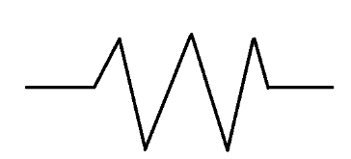
Longer the wire greater will be its electrical resistance, less for a wire of larger cross-sectional area, and it’s also depended upon the material out of which the wire is made.
The resistance of a wire can be expressed as:
$$R=\frac{ρL}{A}$$

Whereas;
ρ = resistivity
L = Length
A = Cross sectional area
- CAPACITOR:
Capacitor is a passive component which store potential difference in an electric field, Capacitance is known as the effect of capacitor. Capacitor consist of two or more parallel conductive plates (metal) which are separated by air or dielectric medium. Due to this dielectric layer, DC current cannot flow through the capacitor as its blocks it.

Mathematical representation:
$$C=\frac{Q}{V}$$
Whereas,
C = Capacitance
Q = Total Charge
V = Voltage
The SI unit of capacitance is farad (F), can be defined as one coulomb per volt (1 C/V). Capacitance values of typical capacitors for use in general electronic range from about 1 picofarad (pF) (10⁻¹² F) to about 1 millifarad (mF) (10⁻³ F).

- POWER SUPPLY:
A power supply is an electrical gadget that provide electric power to an electrical load. The essential function of a power supply is to convert electric current from a source to the right voltage, current, and frequency to control the load. Therefore, power supplies are some of the time alluded to as electric power converters. Power supply converts AC current to DC current. It’s also regulate the DC voltage.
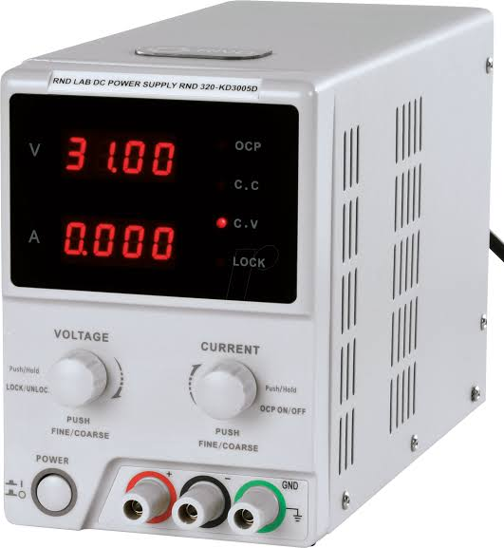
Figure 1: Power Supply

- OSCILLOSCOPE:
An oscilloscope is a laboratory instrument commonly used to display and analyze the waveform of electronic signals. In effect, this device draws a graph of the instantaneous signal voltage as a function of time.
A typical oscilloscope can display alternating current (AC) or pulsating direct current (DC) waveforms having a frequency as low as approximately 1 hertz (Hz) or as high as several megahertz (MHz). Oscilloscope store the digital copy of the waveform in the digital memory which then under goes in the process of digital signal processing. The maximum frequency measured by digital oscilloscope depends upon two things: one is sampling rate of the scope and other is the nature of the converter. Converter is either analog or digital.
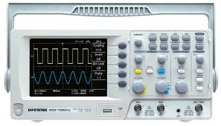
Figure 2: Oscilloscope.

- FUNCTION GENERATOR:
A function generator is a specific form of signal generator that is able to generate waveforms with common shapes. In particular it can be made to become a sine wave generator, square wave generator, and triangular wave generator. Also a function generator may be able to vary the characteristics of the waveforms, changing the length of the pulse etc.
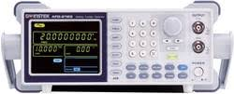
Figure 3: Function Generator

- MULTIMETER:
An instruments design to measure electrical quantities such as voltage, current or resistance. There are two types the analog and the digital multi meter. Digital multimeter not only help full in measuring the value, but it’s also helps us to check the component that it’s working properly or not. It has a function of continuity which is useful to identify the connections. High resolution multi meter have short term errors as low as 0.1 parts per million (ppm). Figure 4 represents a Digital Multimeter.
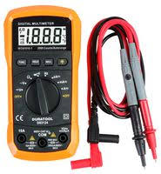
Figure 4: Digital Multimeter
- BREADBOARD:
When building a temporary circuit, we use breadboard which is a soldering less component to test circuit designs. Breadboard is reusable. Designing circuit on this board is relatively easier as it’s easy to change connections and replace components
When wiring it’s important to keep work neat, this will not only save your time but also help you in troubleshooting, keep your wire short, do not loop wire over the chips, Use the bus lines for ground or a DC supply voltage. Breadboard connections are also quite easy. You just have to remember one thing that the columns marked ‘a-e’ on Breadboard are vertically short. Similarly, the columns marked ‘f-j’ are also vertically short. Whereas the all these columns are vertically open. +ve and -ve rail of bread board are horizontally short. This can also be observed in the below figure 6.
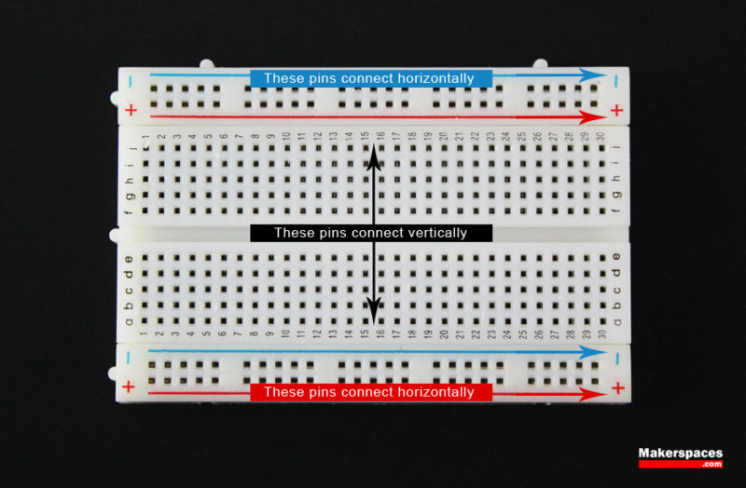
Figure 5: Internal Wiring of Breadboard
  - SERIES CIRCUIT:
In a series circuit, the current through each of the components is the same, and the voltage across the circuit is the sum of the voltages across each component. In a series circuit component are connected in a series, only one end of the component is connected to the one end of another component. Current remains same in a series connection while voltage drop across the loads.

    - FORMULA:
$$R_{T}= R_{1}+R_{2}+ . .. +R_{n}$$
    - CIRCUIT DIAGRAM:
Figure 6: Series Circuit
  - PARALLEL CIRCUIT:
A parallel circuit is one that has two or more paths for the electricity to flow, the loads are parallel to each other. Components are connected from both end with each other. In a parallel circuit, Voltage across all the components remains same while current divide.

    - FORMULA:
$$\frac{1}{R_{T}}=\frac{1}{R_{1}}+\frac{1}{R_{2}}+…+\frac{1}{R_{n}}$$
    - CIRCUIT DIAGRAM:

Figure 7: Parallel Circuit
- TASK 1:
Generate a Sine wave of 100 KHz using oscilloscope and Function Generator.

  - PROCEDURE:
- Open Function Generator and Oscilloscope.
- Connect wires of Oscilloscope and Function Generator on Channel 1.
- Set the function generator for 100 KHz Sine Wave.
- Connect the red wire of oscilloscope to red wire of function generator
- Connect the Black wire of oscilloscope to the black wire of the Function Generator.
- Click the output Button on Function Generator.

  - RESULTS & OBSERVATION:

- TASK 2:
Design the given series circuit on breadboard and connect it with a DC power source. Measure its current, Resistance and Voltage.
CALCULATIONS:

$$Vin (V)$$ | $$R_{1} (Ω)$$ | $$R_{2} (Ω)$$ | $$R_{T} (Ω)$$ | $$V_{R1}(V)$$ | $$V_{R2}(V)$$ | $$I_{R1}(I)$$ | $$I_{R2}(I)$$
5

- TASK 3:
Design the given parallel circuit on breadboard and connect it with a DC power source. Measure its current, resistance and voltage.
CALCULATIONS:

$$Vin (V)$$ | $$R_{1} (Ω)$$ | $$R_{2} (Ω)$$ | $$R_{T} (Ω)$$ | $$V_{R1}(V)$$ | $$V_{R2}(V)$$ | $$I_{R1}(I)$$ | $$I_{R2}(I)$$
5

EXERCISE:

QUESTION 1:
A technician prepares to use an oscilloscope to display an AC voltage signal. After turning the oscilloscope on and connecting the Y input probe to the signal source test points, this display appears:
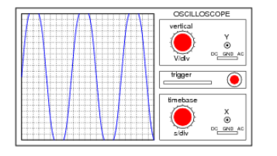
What display control(s) need to be adjusted on the oscilloscope in order to show a normal-looking wave on the screen?

QUESTION 2:
Write the names and symbols of five basic electronic components.
Name | Symbols | Units | Circuit Representation

QUESTION 3:
In what ways we can supply power supply to our circuits?

QUESTION 4:
Explain the difference between series and parallel circuit?

